# Hands-on Lab : Getting Started with PowerPoint for the Web

Estimated time needed: 20 minutes

Microsoft PowerPoint is the most widely used presentation software even three decades after its initial release. For all these years it has been available as a standard application that needed to be installed on your desktop; but it is not just a desktop app anymore. Now, you can even use PowerPoint when you're online by using 'PowerPoint for the web' - and run it right in your web browser without installing anything on your desktop!

'PowerPoint for the Web' (sometimes referred to as PowerPoint Online) can be used at no charge as part of a free Microsoft account. Although it does not have all of the capabilities of the desktop and paid online versions, the free web version provides many of the key features.

# Software Used in this Lab

For the story telling/project report of this module, you will be using the free 'PowerPoint for the web' version as this is available to everyone.

Although you can use the PowerPoint Desktop software if you have access to this version, it is recommended that you use PowerPoint for the web for your project report as it is available for free, and there are some small differences in the interface and available features.

# Objectives

After completing this lab, you will be able to:

* Sign up for a Microsoft Account to use PowerPoint for the web
* Sign in and open a new blank presentation in PowerPoint for the web

# Exercise 1: Sign-up for a Microsoft Account to use PowerPoint for the Web

In this exercise, you will sign up for a Microsoft Account to use PowerPoint for the web.

If you already have a Microsoft account, you can skip Exercise 1 and proceed to Exercise 2 directly.

1. Go to [www.office.com](https://www.office.com/?utm_medium=Exinfluencer&utm_source=Exinfluencer&utm_content=000026UJ&utm_term=10006555&utm_id=NA-SkillsNetwork-Channel-SkillsNetworkCoursesIBMDA0321ENSkillsNetwork21426264-2021-01-01). Click Sign in  
   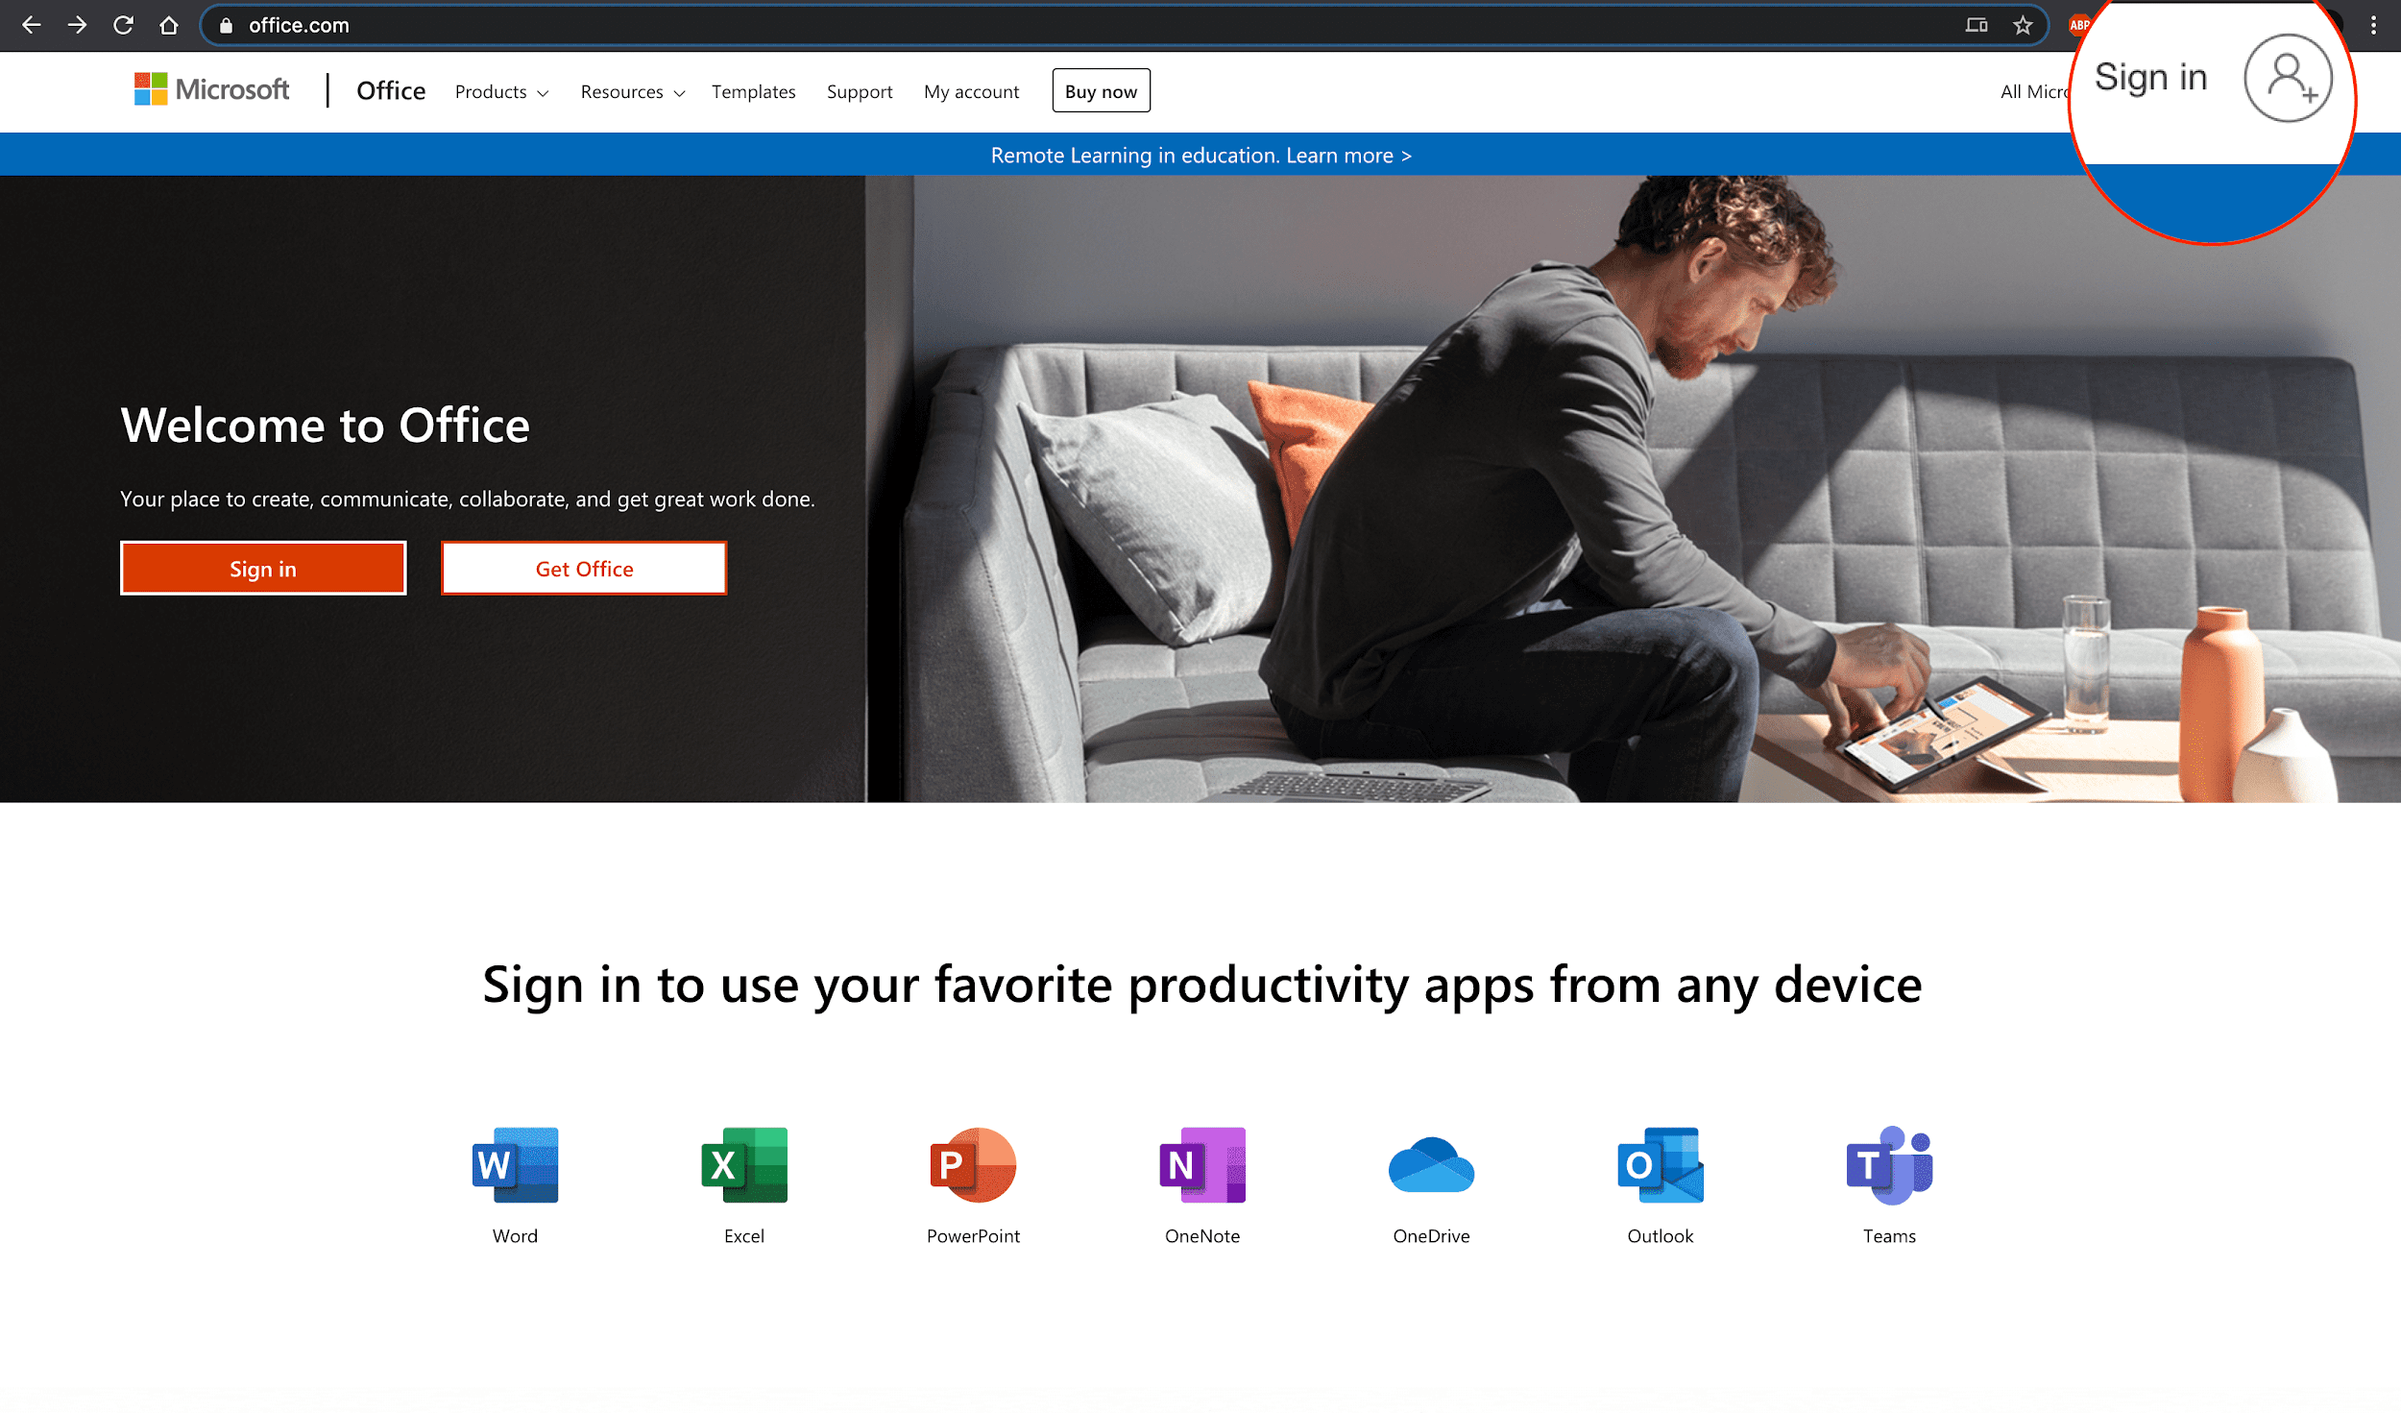
2. Click Create one!  
   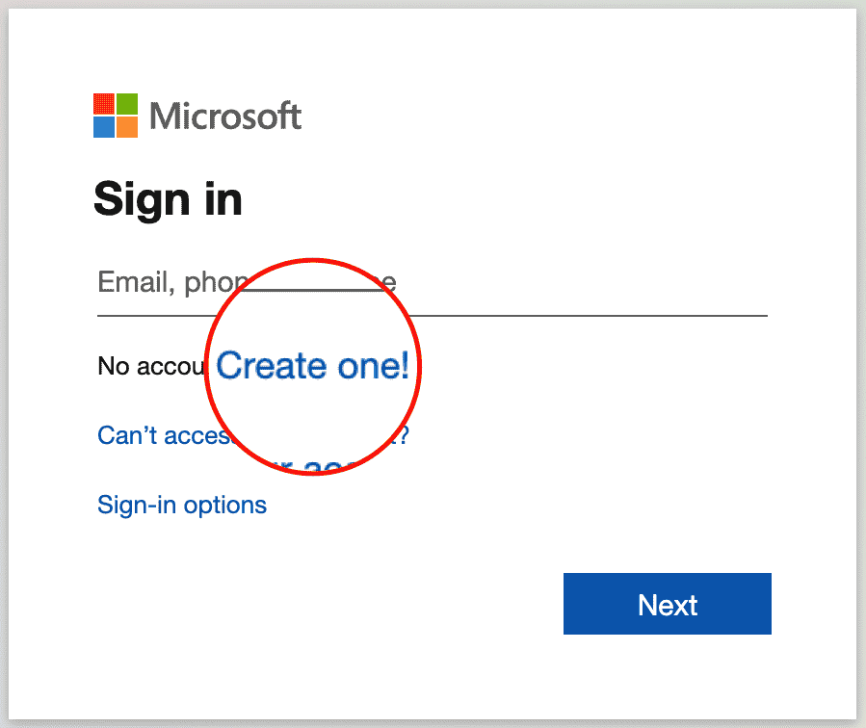
3. Enter your existing email id with which you want to create a Microsoft account. Click Next.  
   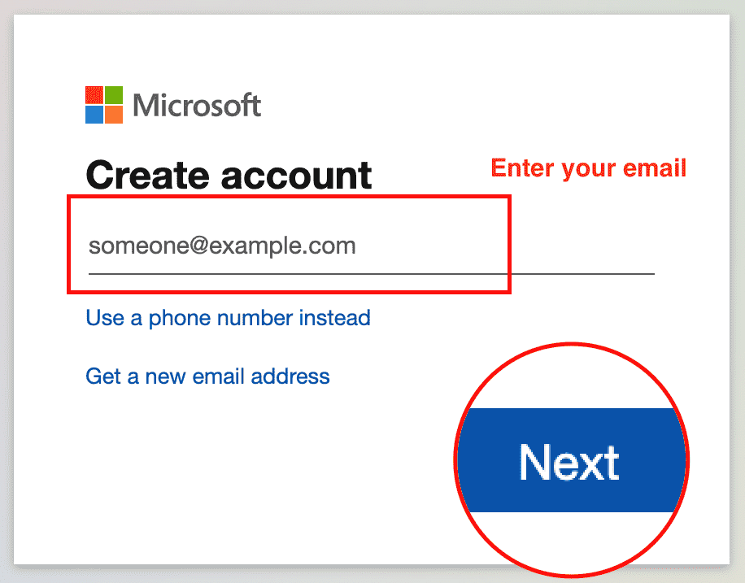
4. Enter your password and click Next.  
   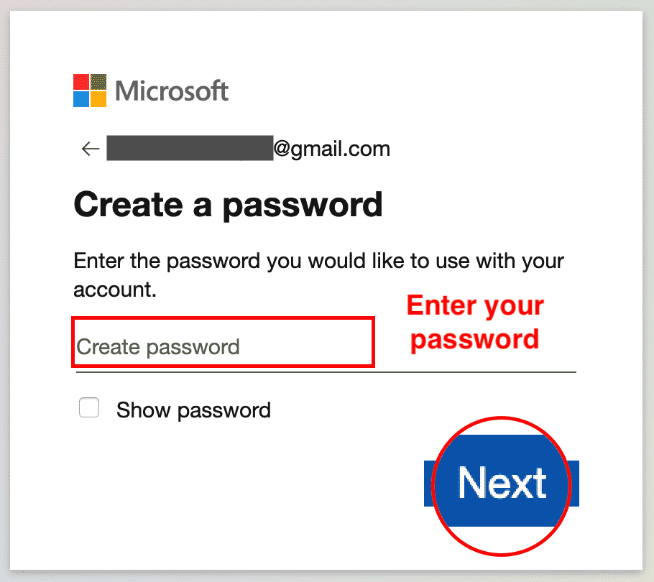
5. Enter the code you received by email. Click Next.  
   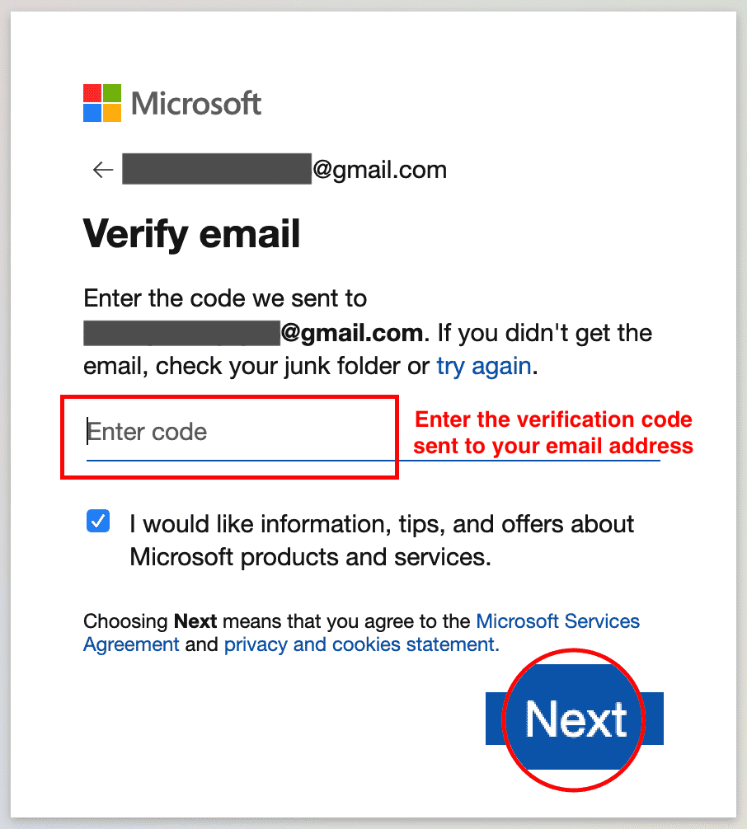
6. Enter your phone number and click Send Code.  
   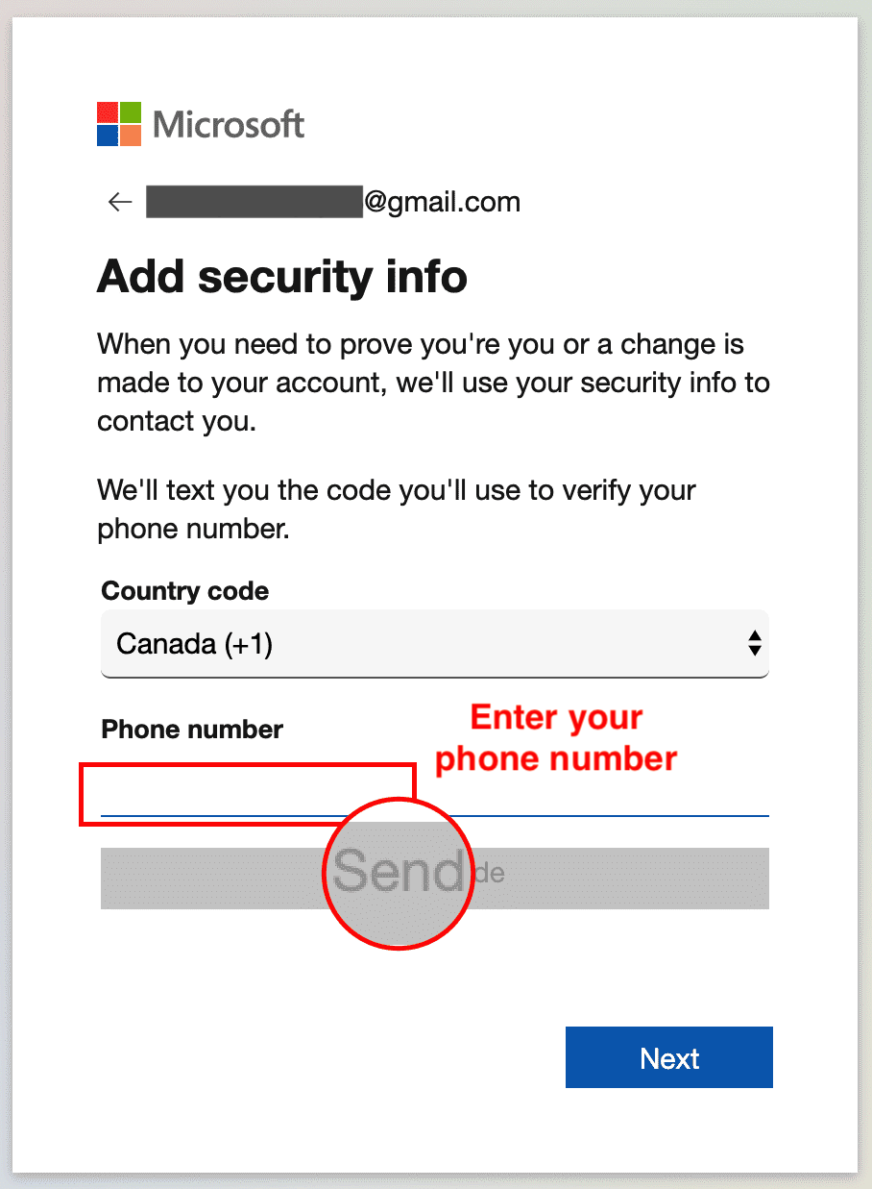
7. Enter the access code you received as a text on your phone, then click Next.  
   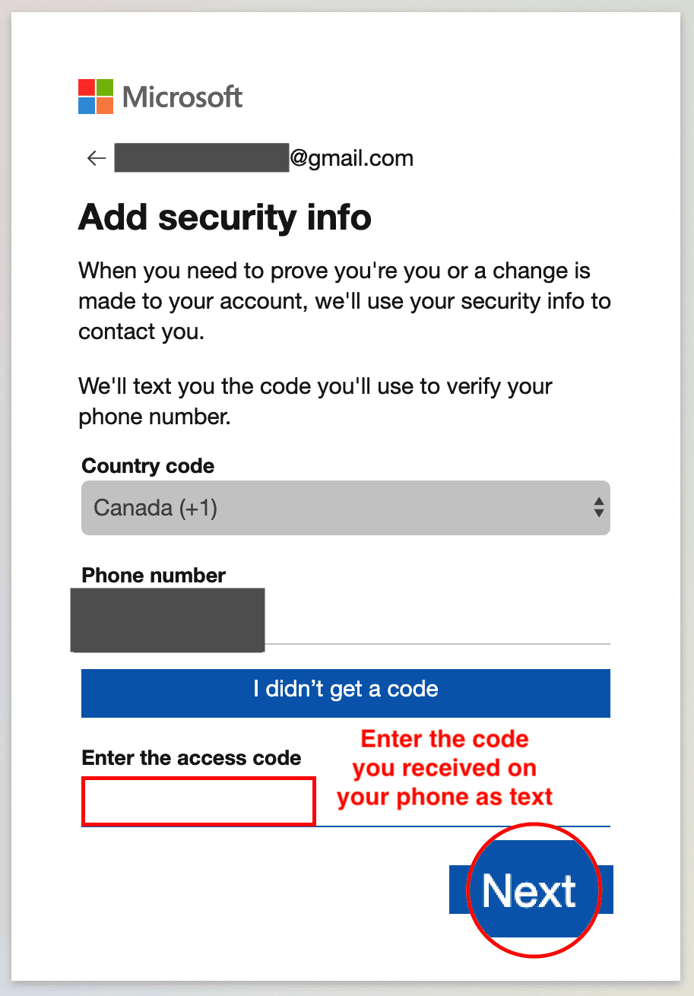
8. You are now done with the sign up procedure. Now since you are signed in after sign up at this stage, you can proceed directly to Task B of Exercise 2.  
   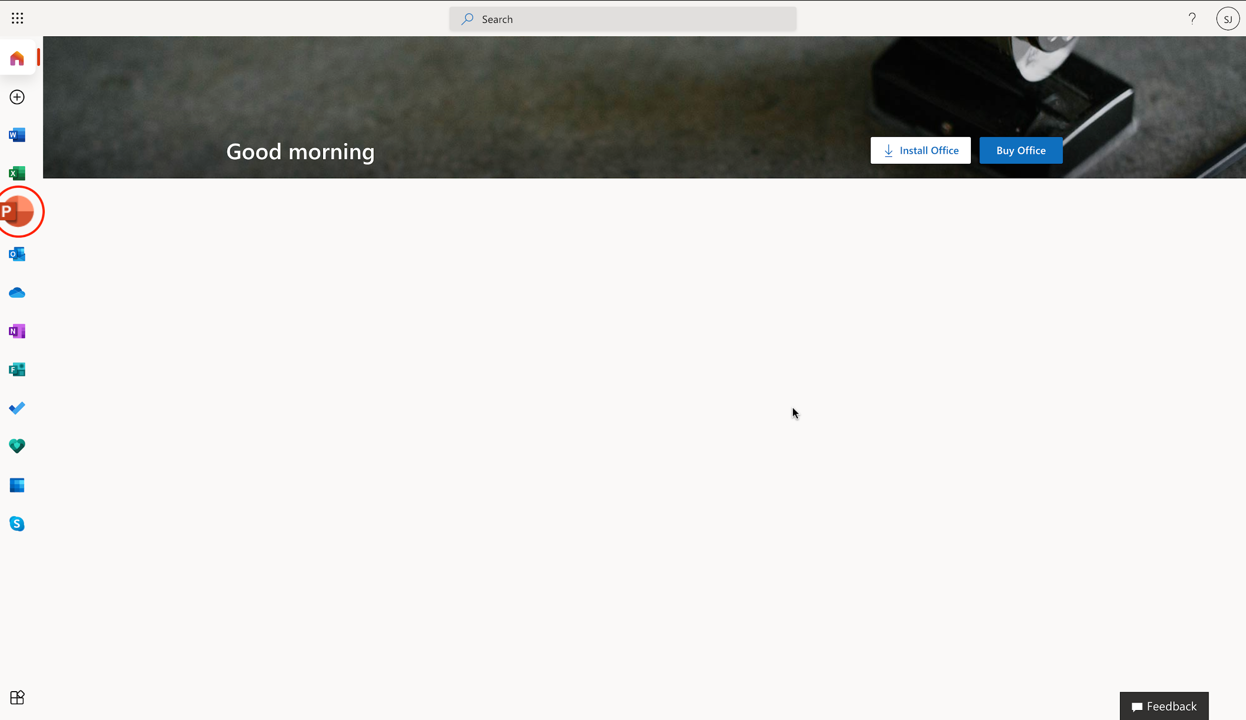

# Exercise 2: Sign-in, Upload and Open presentation in PowerPoint for the Web

In this exercise, you will sign in to PowerPoint for the web. Then open a new blank presentation. Lastly upload, open and edit a presentation.

## Task A: Sign in to PowerPoint for the Web

1. Go to [www.office.com](https://www.office.com/?utm_medium=Exinfluencer&utm_source=Exinfluencer&utm_content=000026UJ&utm_term=10006555&utm_id=NA-SkillsNetwork-Channel-SkillsNetworkCoursesIBMDA0321ENSkillsNetwork21426264-2021-01-01). Click Sign in.  
   
2. Enter your sign in email.  
   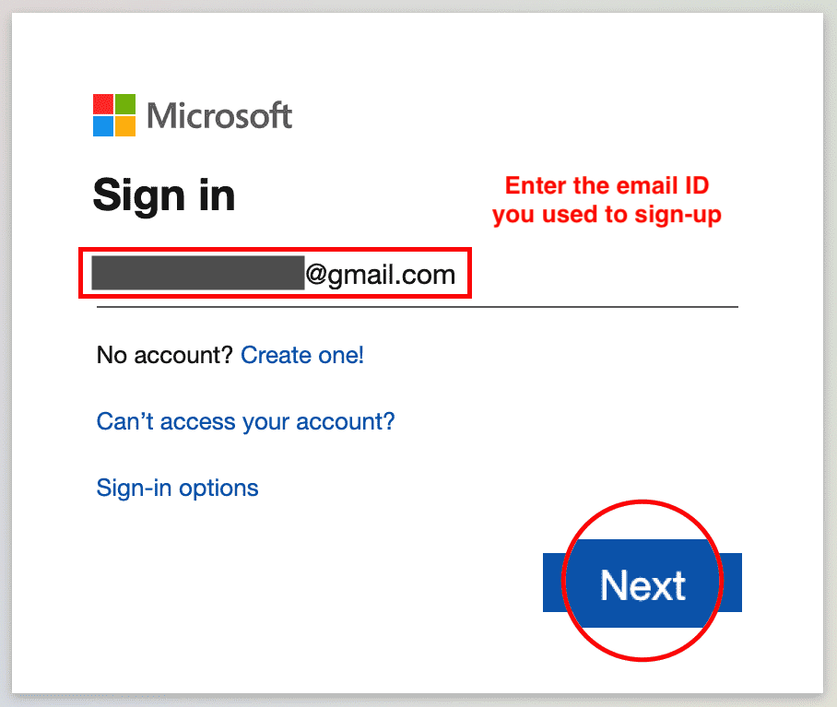
3. Enter your password.  
   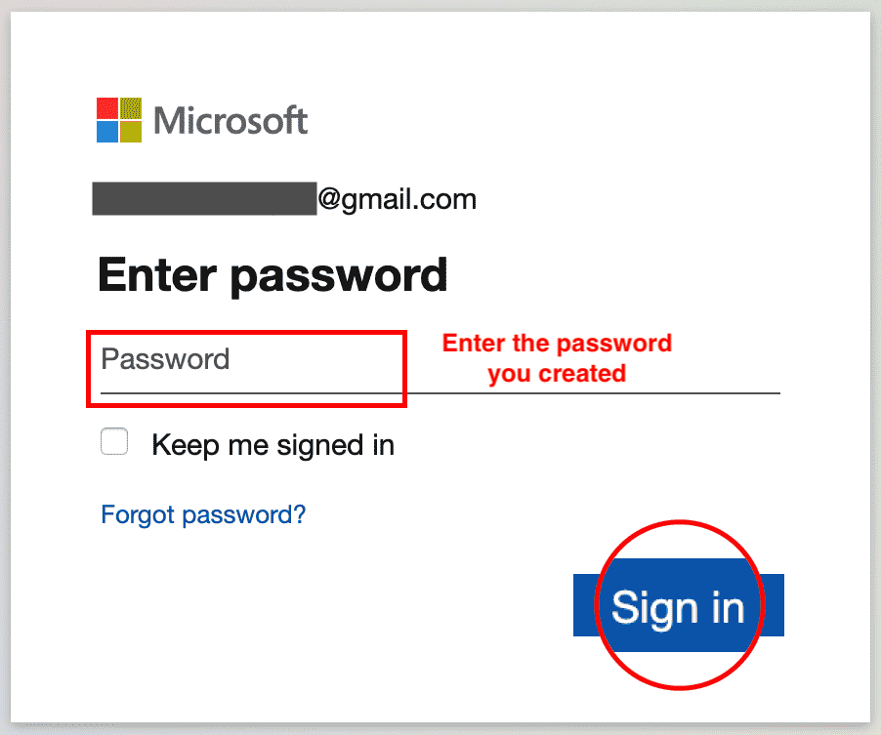
4. You are now signed in.  
   

## Task B: Open a new blank presentation in PowerPoint for the Web

1. Click on the PowerPoint icon.  
   
2. Click New blank presentation.  
   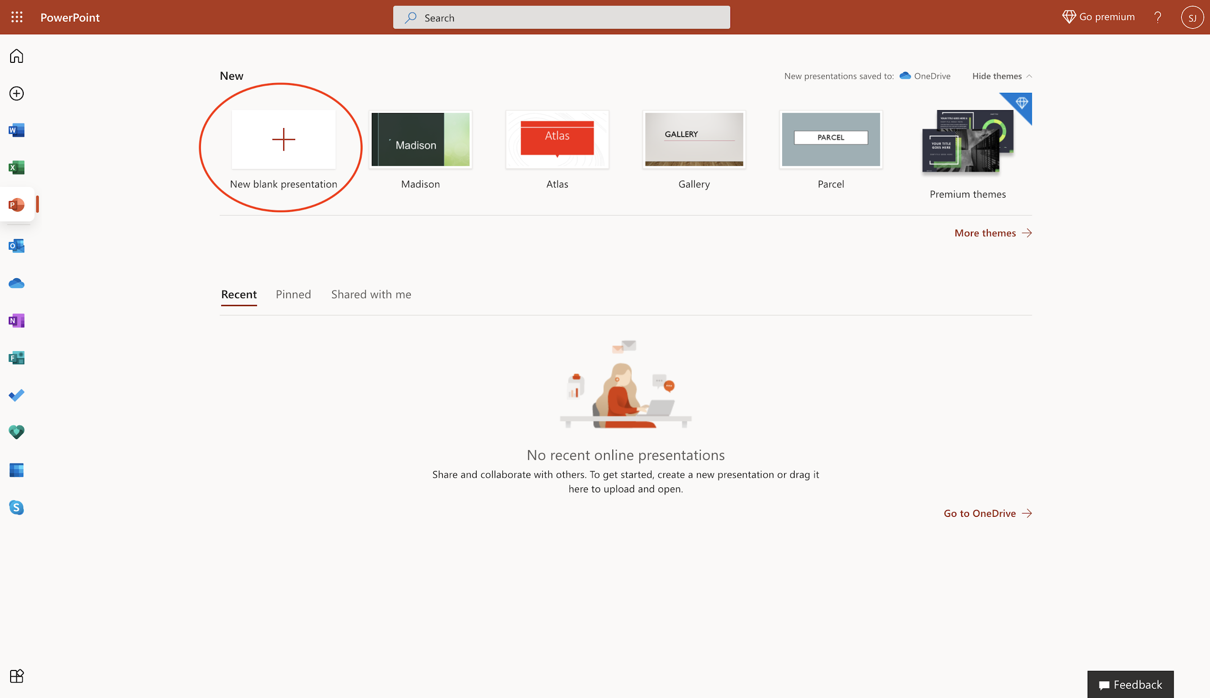
3. You have successfully opened a new blank presentation in PowerPoint for the web.  
   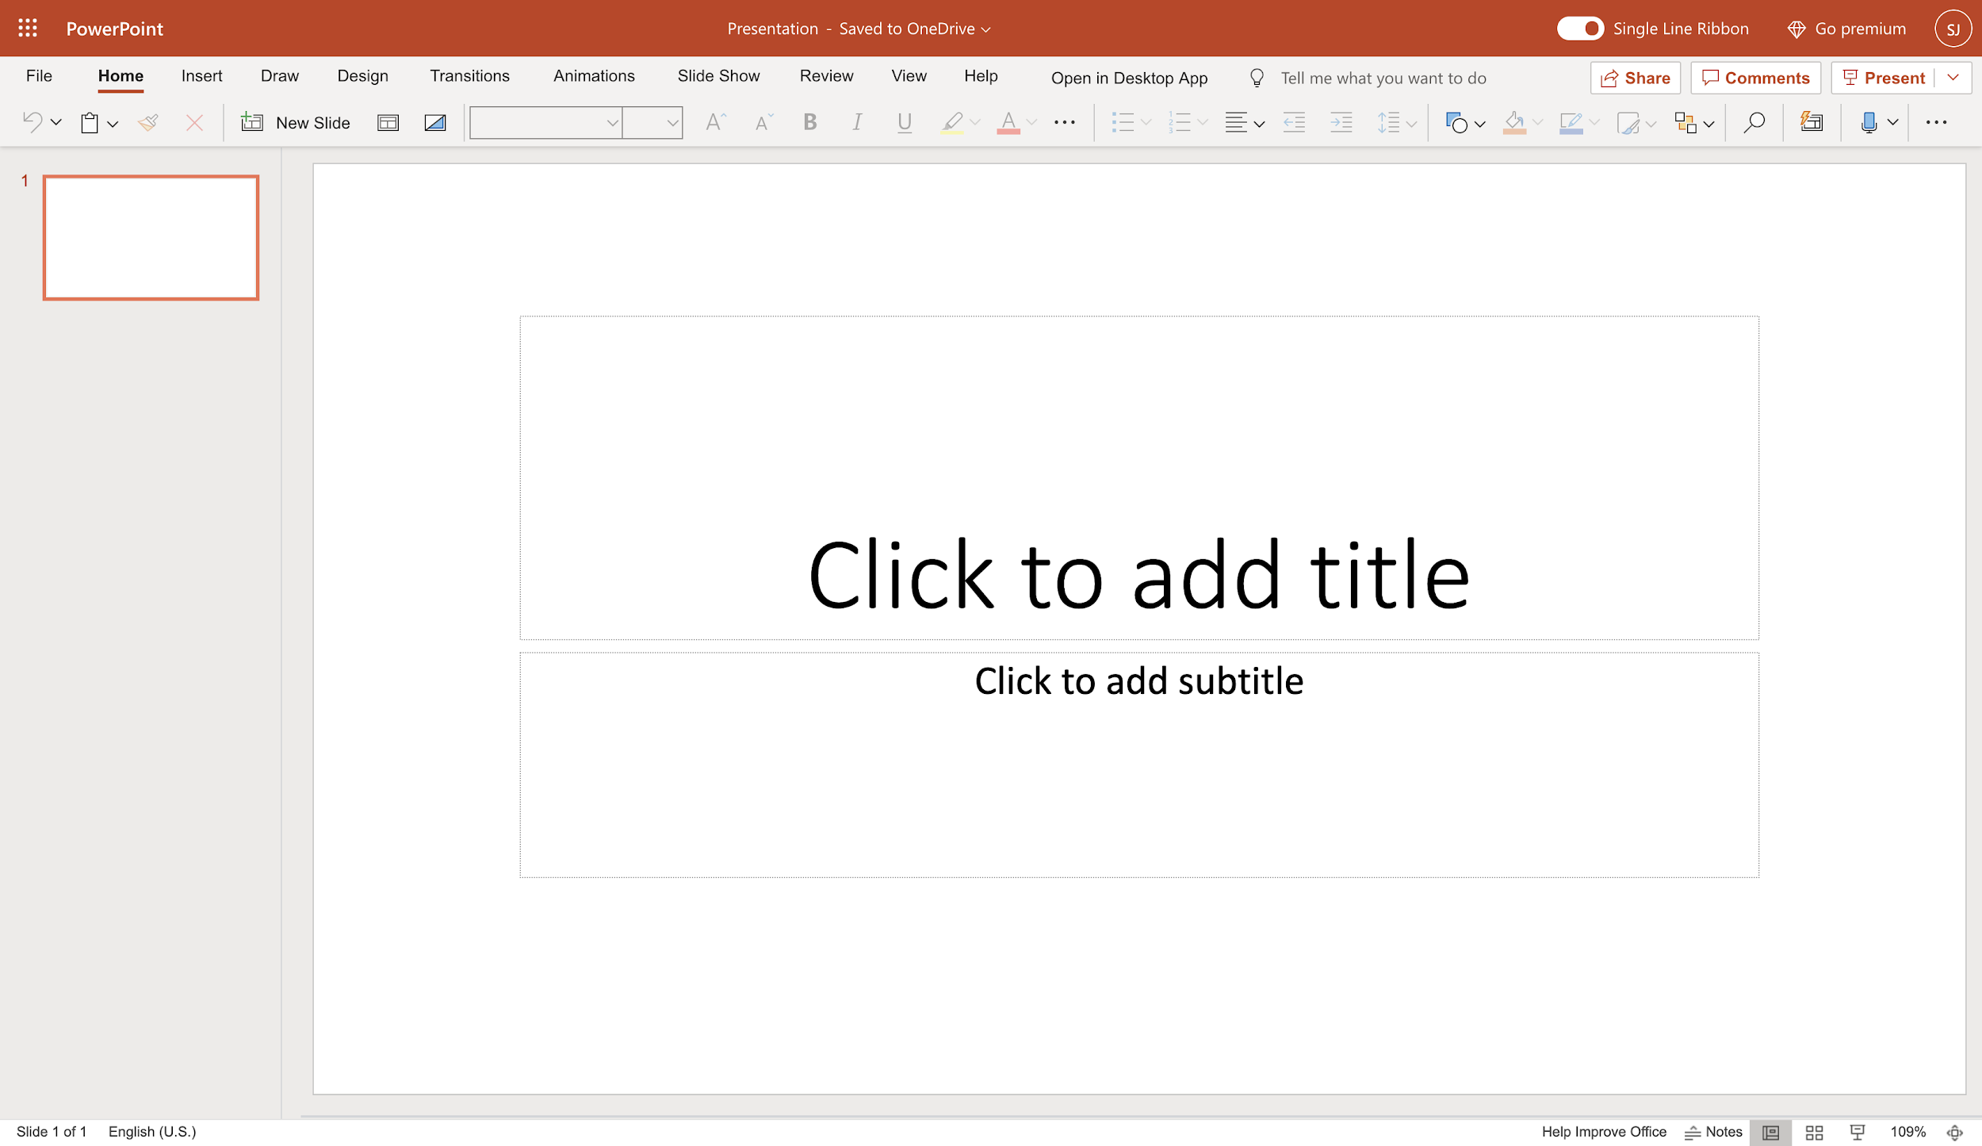

## Task C: Upload, Open and Edit a Presentation

1. Download the file [capstone-story-template.pptx](https://cf-courses-data.s3.us.cloud-object-storage.appdomain.cloud/IBM-DA0321EN-SkillsNetwork/labs/module%206/Lab%20-%20Getting%20Started%20with%20PowerPoint%20for%20the%20Web/capstone-story-template.pptx).
2. To upload and open a presentation file in PowerPoint for the web, click the App Launcher (cube of dots) in the top left corner. Click PowerPoint icon.  
   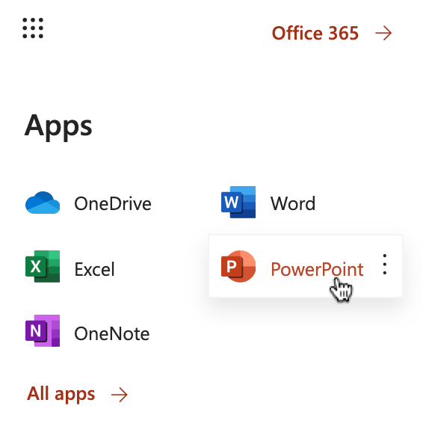
3. Click Upload and open... and select the capstone-story-template.pptx file.  
   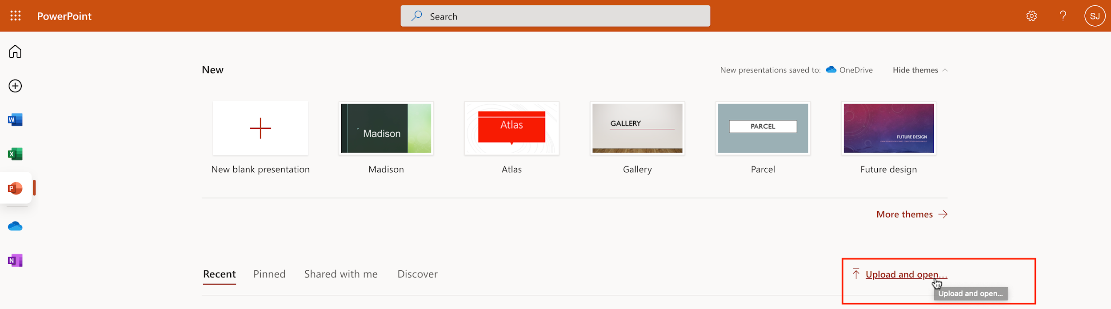
4. The file will be uploaded to your OneDrive of the Microsoft Account you signed up and used to open PowerPoint for the web.  
   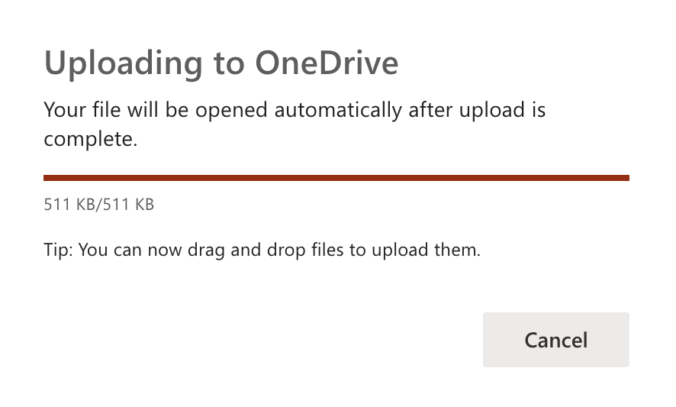
5. Now edit the presentation with your information required for this module. Your edits are saved automatically.  
   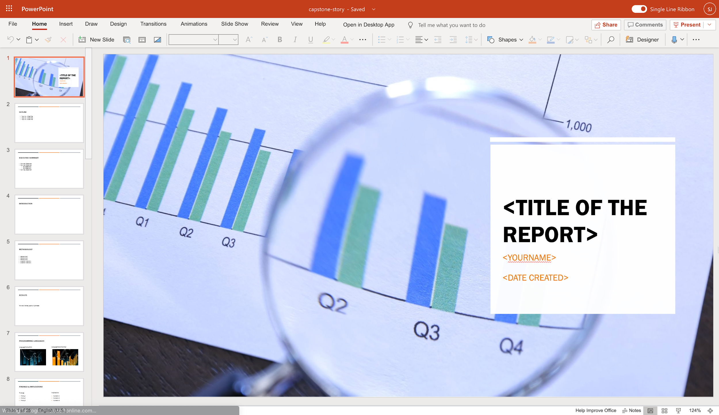

### Congratulations! You have completed this Lab.